**ASSIGNMENT 1**

Name: Kulsoom Khurshid

Reg#: Sp20-BCS-044

Course: Theory Of Automata

**Question 1)**

1. **Draw DFA and NFAs for the following languages. Also write their regular expressions**

* 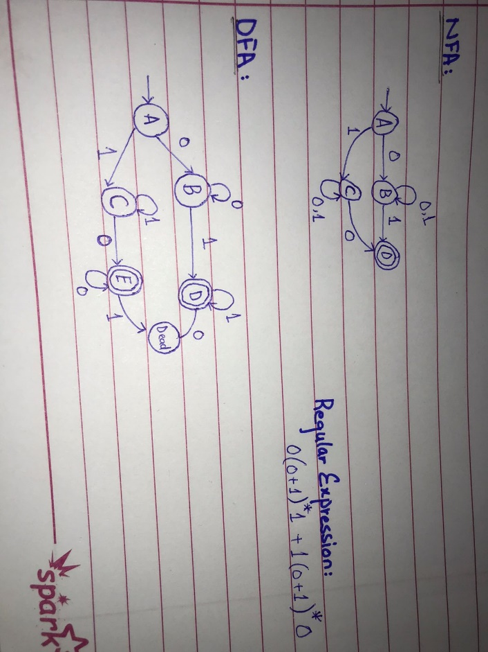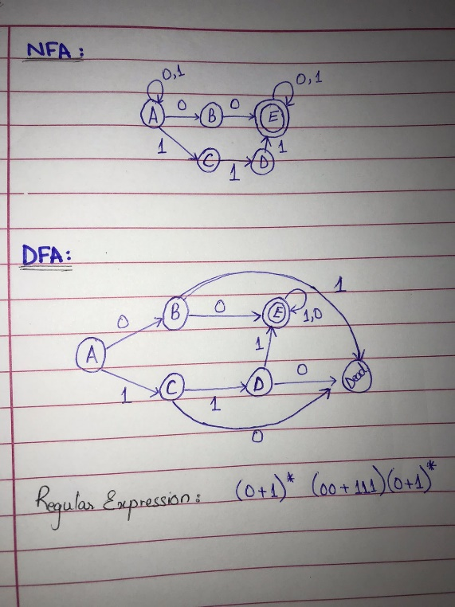**Language of all strings having double 0s or triple 1s over alphabet {0,1}**
* **Language of strings starting and ending with different letters over alphabet {0,1}**
* **Language that accepts all user defined variables/identifiers and any 5 special keywords of the C language over alphabet {a,b,c…z,0,1,….} (Hint: Any combination of letters can be expressed as [a-z]* and numbers as [0-1]* )**

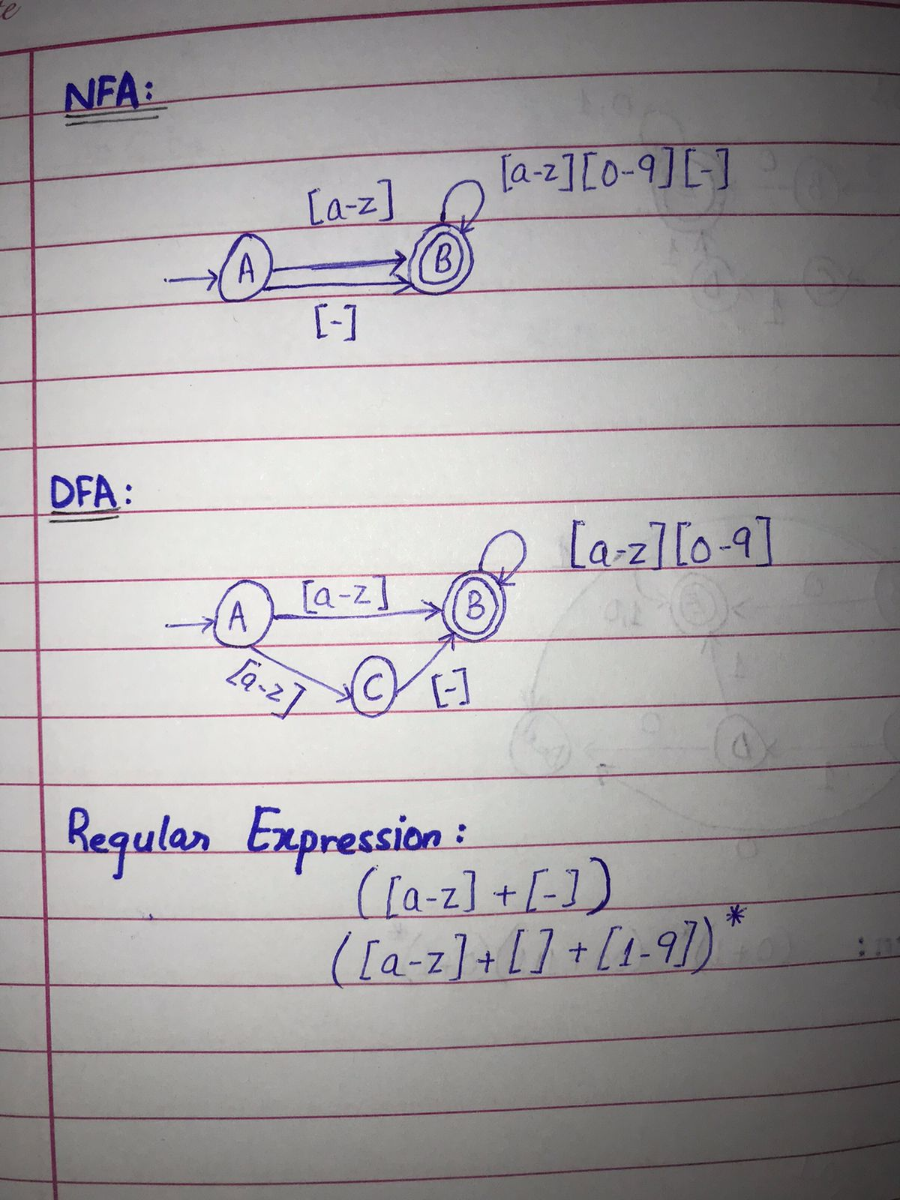

1. **Write regular expression after state elimination method for the following.**

|  |  |  |
| --- | --- | --- |
| States | 0 | 1 |
| P | S | P |
| Q | P | S |
| R | R | Q |
| S | Q | R |

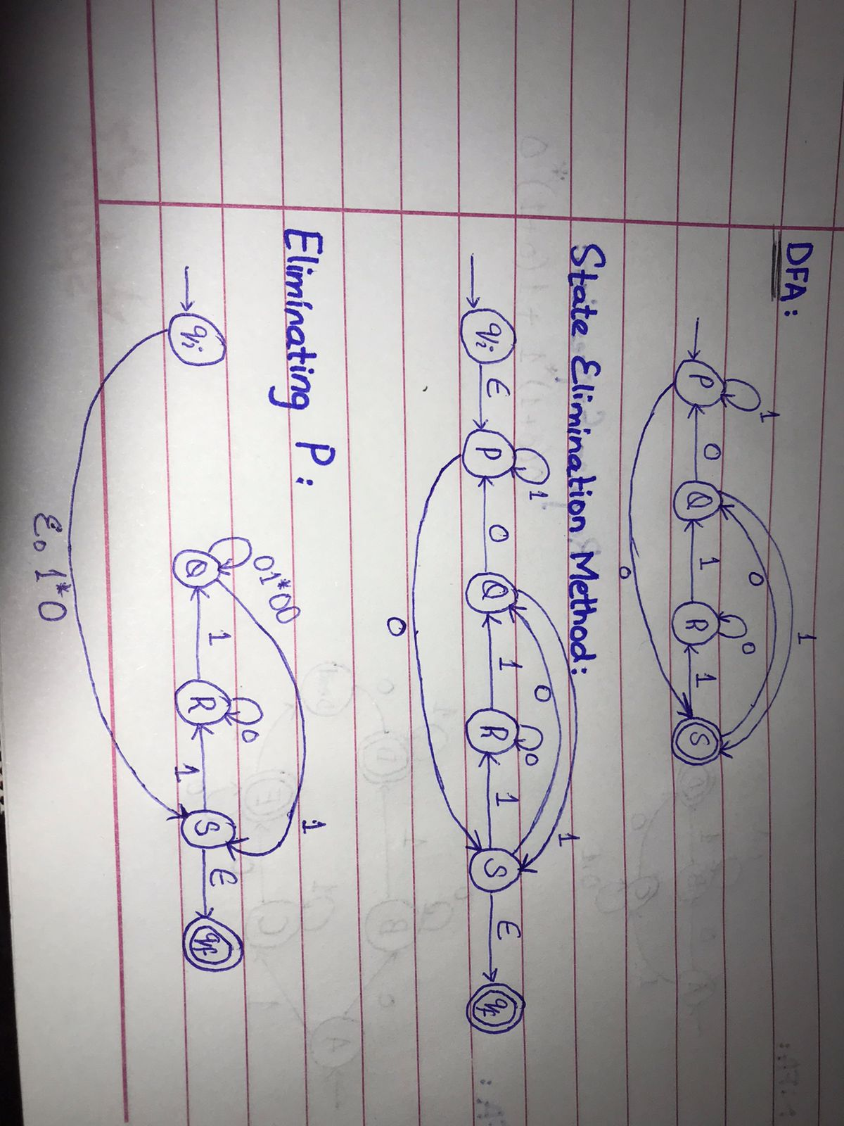

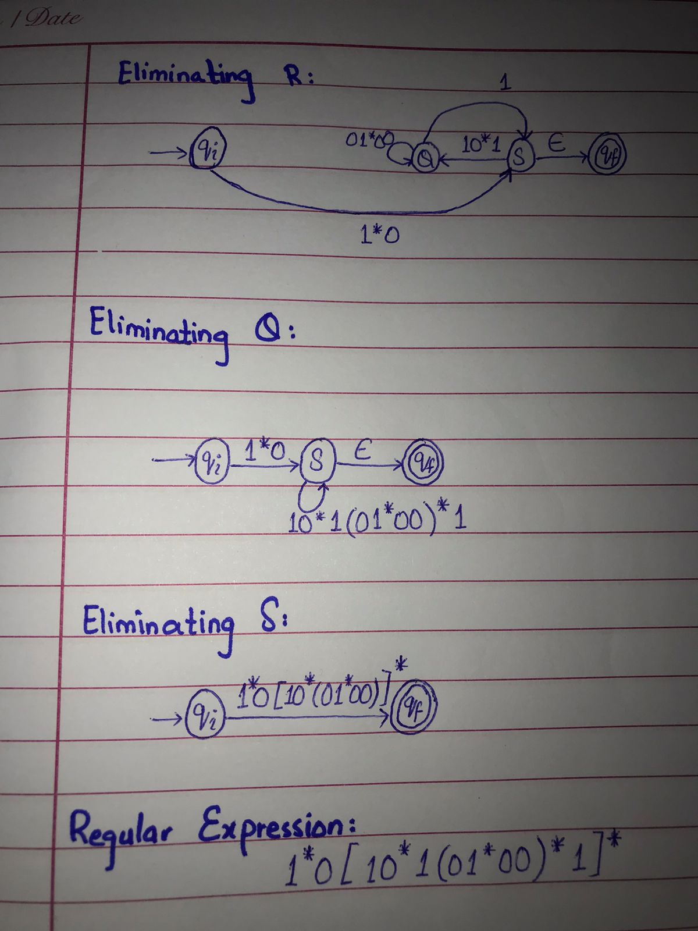

1. **Convert the following NFA-epsilon to DFA.**

**(ɛ+0)(0*10)*(ɛ+11)**

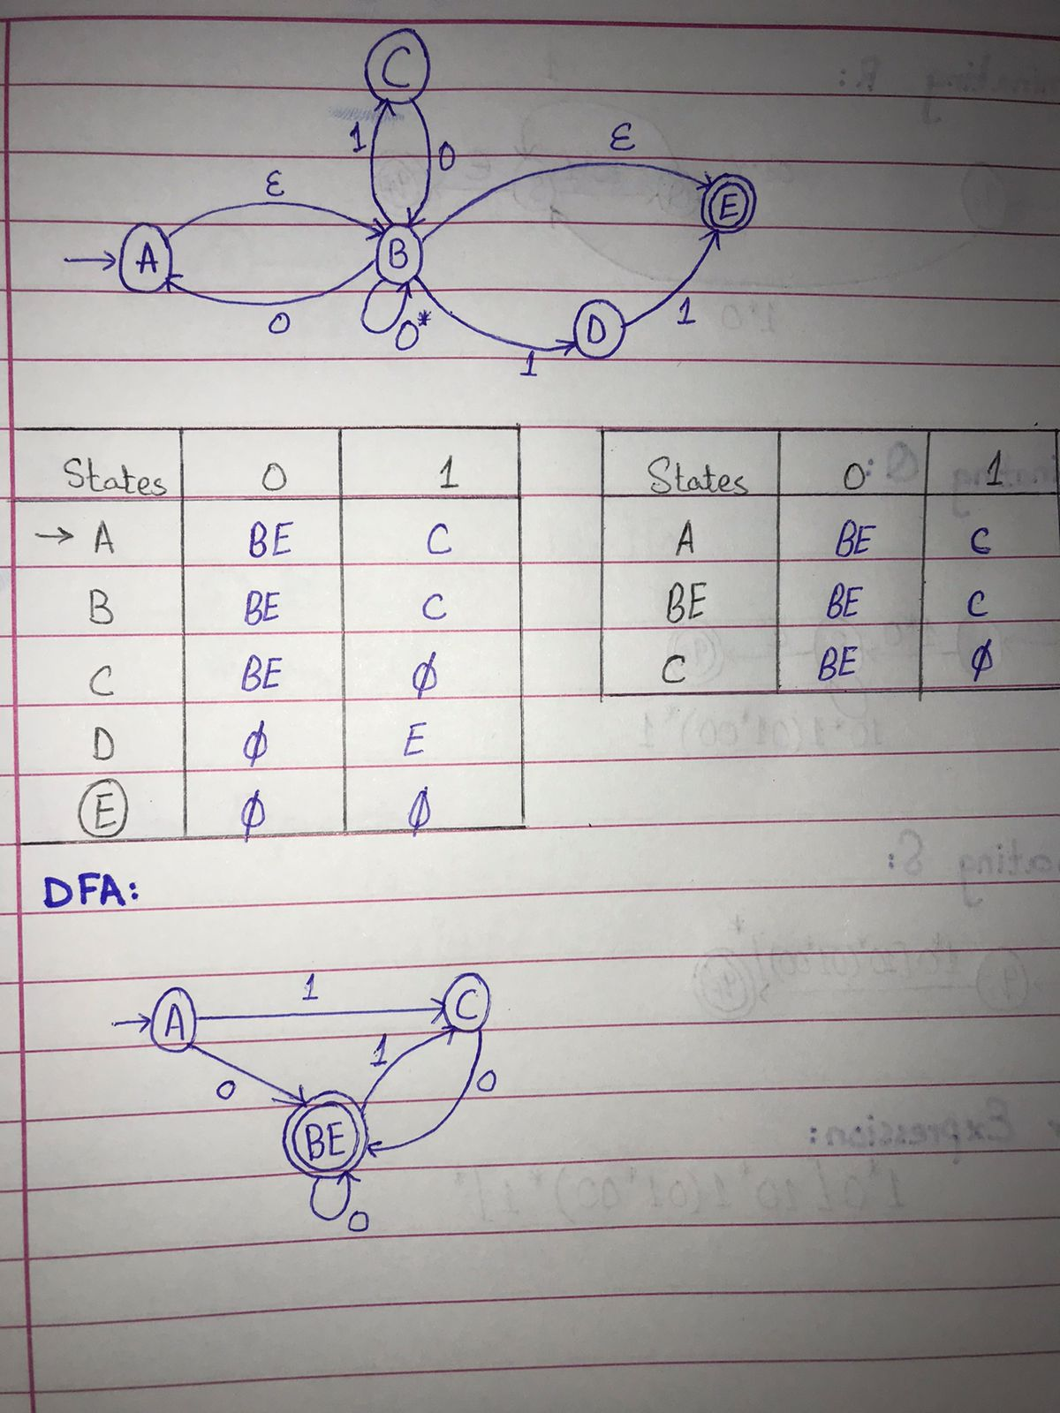

**Question 2) Answer the following questions.**

1. **How computer registers store values? Can we use state diagrams to demonstrate their behavior?**

Registers

Registers are collection of flip flops. Its core functionality is to store the information in its digital system so that it’s available to the logical unit during the computation. However, it may have more capabilities that are associated with it. There are many types of registers that are in use. As registers are flip flops, so it has an input which is changed whenever it is activated it changes the stored values and when it is deactivated the value remains same.

The CPU is made up of registers. Local bus is used to connect with the cache. Cache store the data that is then transferred to registers and from there to ALU. The reverse process to send the result from ALU to cache. In the end cache sends it to main memory which is then displayed to input and output devices. The following state diagram demonstrate the process.

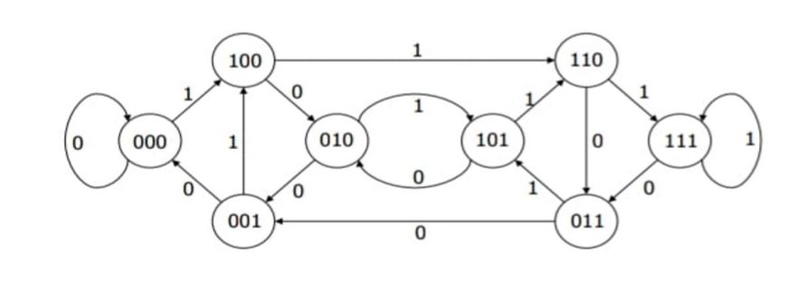

1. **Explain the working of 2-bit and 3-bit counters along with their DFAs. Also mention their use in computer electronics.**

Counter

A counter is usually used to store rarely to display a number of times a particular event has occurred in response to a clock signal. In digital electronics it is used as a counter which count a specific event occurring for a specific time. Counters are sequential circuit that count the number of pulses can be either in binary code or BCD form.

2-bit Counter

It is made of D-type flip flops that is configured as divide by 2 counters because each output’s worth is twice as much as the previous one therefore it requires twice as many clock pulses to make it high. Its output is represented as 0 when low and 1 as high.

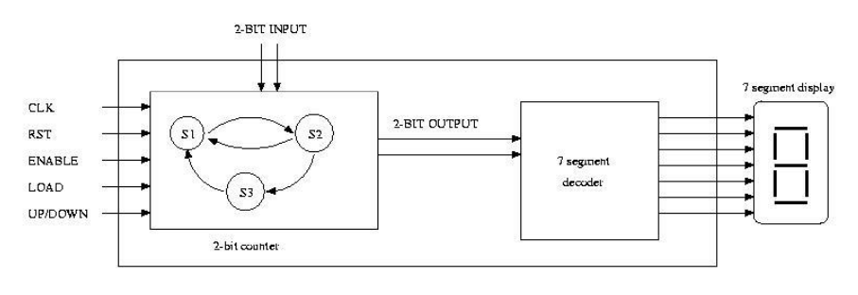

3-bit Counter

This counter contains three flip flops and the input of all the flip flops are connected to 1. These flip flops are triggered negatively but the output change asynchronously. The clock signals are applied directly to the first flip flop.

Working

* The mode control input decide which sequence will be generated by the counter.
* The mode control input decide whether the counter will perform up counting or down counting.
* Designing of such a counter is the same as designing a synchronous counter but the extra combinational logic for mode control input is required.

1. **Explain the working of 2-bit and 3-bit shift registers along with their DFAs. Also mention their use in computer electronics.**

2-bit shift Registers

It consist of two D flip flops connected in a chain. This allows you to “shift” the stored item through this chain of flip flops.

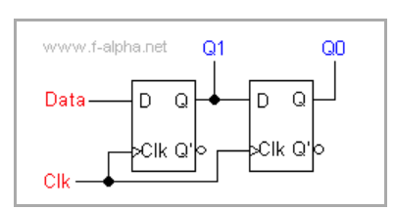

According to the diagram, the output of Q1 flip flop is attached to the D input of another flip flop. Both of the flip flops uses clock signal directly. Hence, all the flip flops switch synchronously.

Working

When you press the Clk push button clock signal is triggered.

* The first signal the data value is stored and displayed.
* At second signal, Q1 value is stored on the second flip flop which is displayed at Q0. Simultaneously a new value is stored and displayed at Q1.

The stored value is successfully shifted by one flip flop towards the right.

3-bit shift Registers

In Serial In Parallel Out shift register, the data is stored Serially while its retrieval is in parallel manner. A 3-bit synchronous SIPO shift register is sensitive to positive edge of the clock pulse. The data word is fed in serial way at the input of first flip flop. Also in the figure the input of other flip flops are driven by the preceding outputs. In this kind of shift register, the data stored within the register is obtained as a parallel-output data word (Data out) at the individual output pins of the flip-flops (Q1 to Q3).

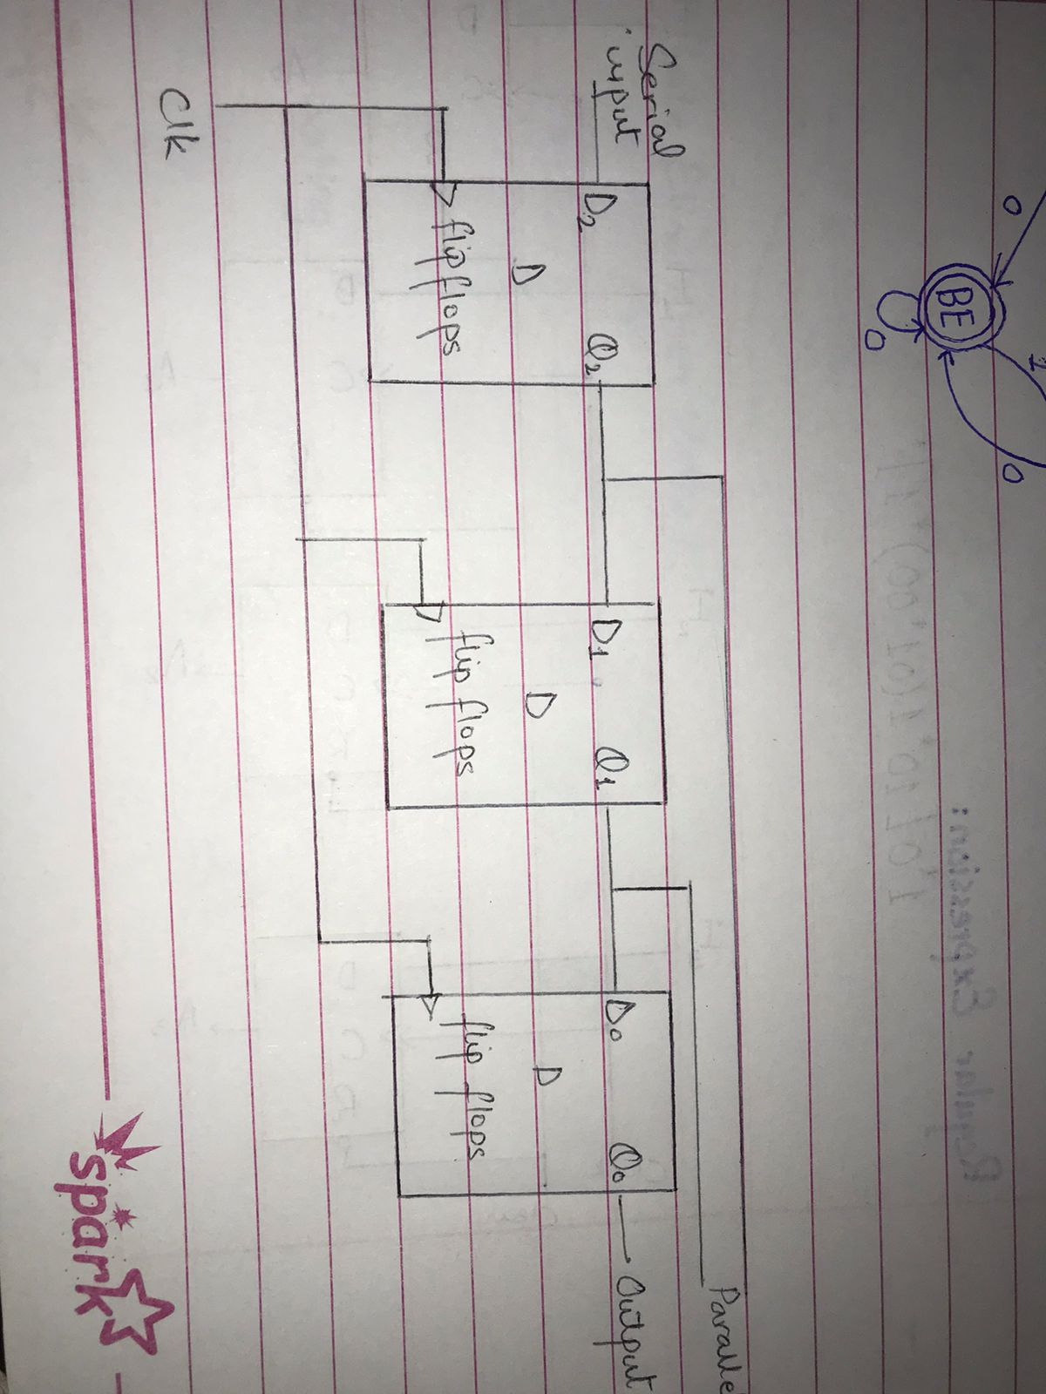

The logic circuit given below shows a serial-in serial-out shift register. The circuit consists of four D flip-flops which are connected in a serial manner. All these flip-flops are synchronous with each other since the same clock signal is applied to each flip flop.

1. **Explain the working of any Vending Machine along with its DFA with output.**

Working

Suppose a vending machine does the following task.

* Accept $1 and $2 coins.
* It refunds all the money if coins are more than $4.
* It delivers if exactly $4 are added.

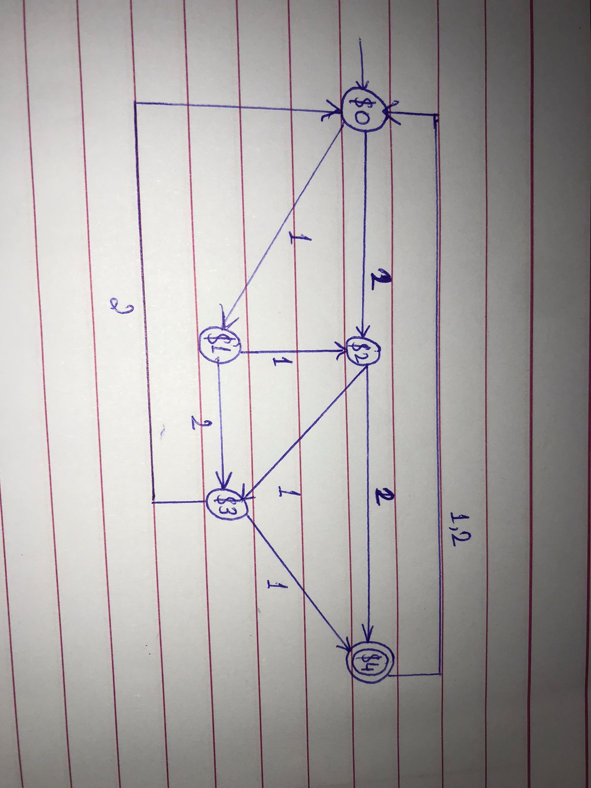

* Initial state is ‘$0’ and final state is ‘$4’
* Alphabet = ∑ = {1,2}